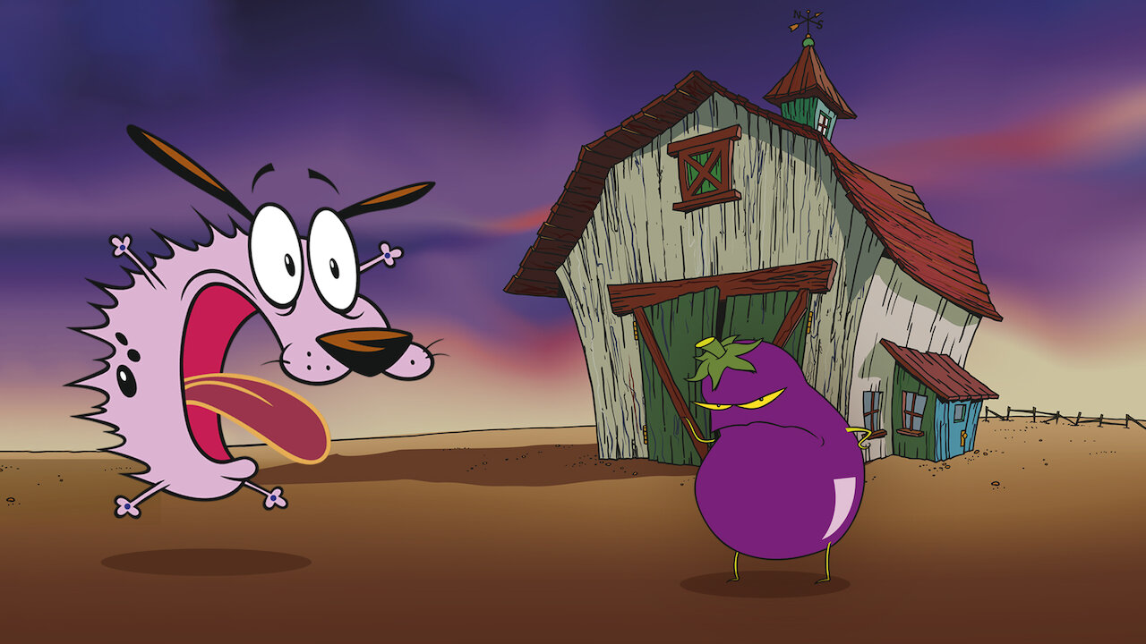
Recalling the good old Cartoon Network days, many cartoons hit us with nostalgia, and "Courage the cowardly dog show" certainly stands tall amongst those.

The unique combination of horror,sci-fi, comedy, and offbeat elements put it amongst the masterpieces of the golden age of cartoons - for my generation.
.
Many fanfictions and theories have been made, discussed, and pondered upon in its context, and many are mind-boggling at times.
.
Courage has been called a "hell hound" for his shape-shifting abilities, and that he's protecting Muriel (Earth) from all the ugly elements of hell, represented by the monsters, with Eustace being his master, who is the embodiment of hell's hate.

Another theory, a fairly striking one, connects the show to be loosely based on a town called Truth and Consequence, New Mexico.

The house in the show and its surroundings are highly idiosyncratic to a real house, which had witnessed murder and dual kidnapping, while the actions/methods of the villains were based on an actual 𝙎𝙚𝙧𝙞𝙖𝙡 𝙠𝙞𝙡𝙡𝙚𝙧 named David Parker Ray, active in the same area, said to have committed 40-60 murders, which remain unproven.

The theory which I personally love the most is that the whole show is based on the dog's perspective, and that he sees every unfamiliar person as a monster and wants to protect their owners from them, and that his owners are old and hence rarely take him for a walk, causing his perspective of the world to be very limited and causing him to believe he lives in the middle of nowhere.

I do not want to present a theory, but an articulation of what courage felt like to me, growing up.
When I look at courage,he basically fits the description of a paranoid person, who gets bombarded with anxiety at the slightest hint of conflict and suspicion. But before we just brand him as a coward, it would be nice to have a look
at his backstory.

As a puppy, Courage had his head stuck in metal grills, and his biological parents took him to a vet, who, although he freed him, abducted his parents and sent
them off to space. Courage, even at a young age, chose to fight back, but couldn't save his parents. This trauma left a subconscious mark on him, and each hint of threat makes his
system go haywire, and makes him put herculean efforts to save those he loves and is loyal to, because he doesn't want to lose them too.

The series to me is more about mental health and judgement of people.

Courage is hyperactive when tense, and his speech patterns are mostly gibberish, representing an inability to express what he's feeling through words.

He even shape shifts to transform into monsters that he wants his parents to be aware of, but they do not notice, why? because these vivid expressions are in his head, just like we have our insecurities and fears, which take forms in our head, and we expect people whom we love to see them just by looking into our eyes, but that does not happen.

Muriel is too kind, loving, and at times, naïve, whereas Euestus is on the other end of the spectrum, with a more materialistic, conservative, inconsiderate approach towards things, a simple man, trying to protect his peace, living on his own terms.

Both try to comprehend Courage's condition in simple, straightforward ways, and often fail, Eustace more so, because of his troubles with empathising

Things get out of hand when Courage's fears turn out to be true, and the issues, the demons, the monsters, start getting a hold of the family. This is when courage himself has to step out of his comfort zone, and handle the issue by himself. Ironically, the couple tends to forget what happened every new episode, signifying how our issues and perspective remain personal to us, no matter how hard we try to explain them, and we rarely get truly understood, even by our closest ones.

The show essentially depicts how a misfit, regardless of if he's understood by his dear ones or not, regardless if he get appreciated or not, regardless of being hurt (even assaulted), helps those who need him.

Because he knows, deep down, what losses are, and he knows what hurt is
like. He knows what it is like to lose everything. He has his insecurities; he messes up too, but in the end, he comes to terms with the fact that he is the way he is.

Courage does freak out, but he never turns his back to problems; you could just wish he could explain himself better and not go completely
nuts, but Courage, indeed, isn't a coward.
Showing up is Courage.

